Name: Sakshi Sunil Gadade
Roll No:43
Assignment no-4

Problem Statement:
Thread synchronization using counting semaphores. Application to demonstrate: producer consumer problem with counting semaphores and mutex.

Code :
#include <stdio.h>
#include <pthread.h>
#include <semaphore.h>
#include <stdlib.h>

#define MaxItems 5
#define BufferSize 5

sem_t empty;
sem_t full;
int in = 0;
int out = 0;
int buffer[BufferSize];
pthread_mutex_t mutex;

void *producer(void *pno)
{
int item;
for(int i = 0; i < MaxItems; i++) {
item = rand(); // Produce an random item
sem_wait(&empty);
pthread_mutex_lock(&mutex);
buffer[in] = item;
printf("Producer %d: Insert Item %d at %d\n", *((int *)pno),buffer[in],in);
in = (in+1)%BufferSize;
pthread_mutex_unlock(&mutex);
sem_post(&full);
}
}

void *consumer(void *cno)
{
for(int i = 0; i < MaxItems; i++) {
sem_wait(&full);
pthread_mutex_lock(&mutex);
int item = buffer[out];
printf("Consumer %d: Remove Item %d from %d\n",*((int *)cno),item, out);
out = (out+1)%BufferSize;
pthread_mutex_unlock(&mutex);
sem_post(&empty);
}
}

int main()
{

pthread_t pro[5],con[5];
pthread_mutex_init(&mutex, NULL);
sem_init(&empty,0,BufferSize);
sem_init(&full,0,0);

int a[5] = {1,2,3,4,5}; //Just used for numbering the producer and consumer

for(int i = 0; i < 5; i++) {
pthread_create(&pro[i], NULL, (void *)producer, (void *)&a[i]);
}
for(int i = 0; i < 5; i++) {
pthread_create(&con[i], NULL, (void *)consumer, (void *)&a[i]);
}

for(int i = 0; i < 5; i++) {
pthread_join(pro[i], NULL);
}
for(int i = 0; i < 5; i++) {
pthread_join(con[i], NULL);
}

pthread_mutex_destroy(&mutex);
sem_destroy(&empty);
sem_destroy(&full);

return 0;

}

Output :
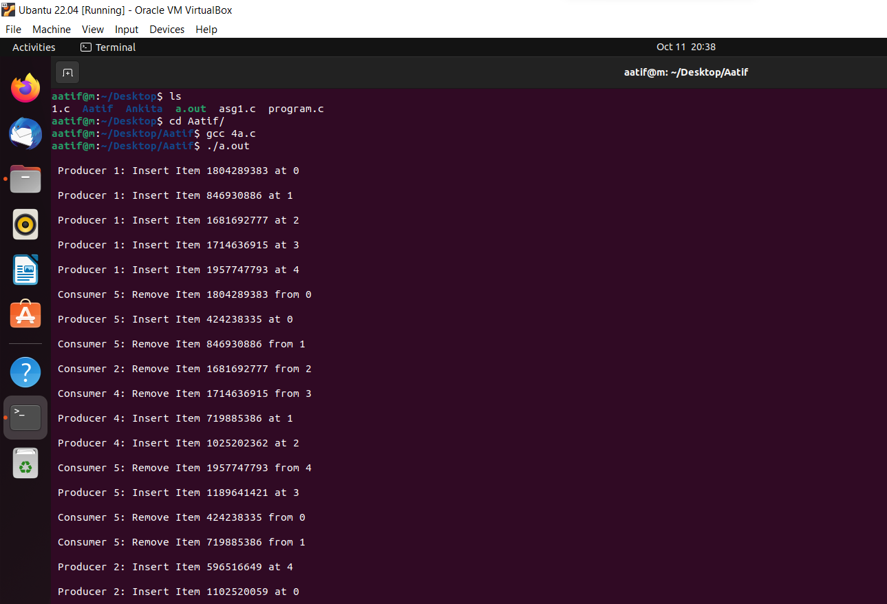

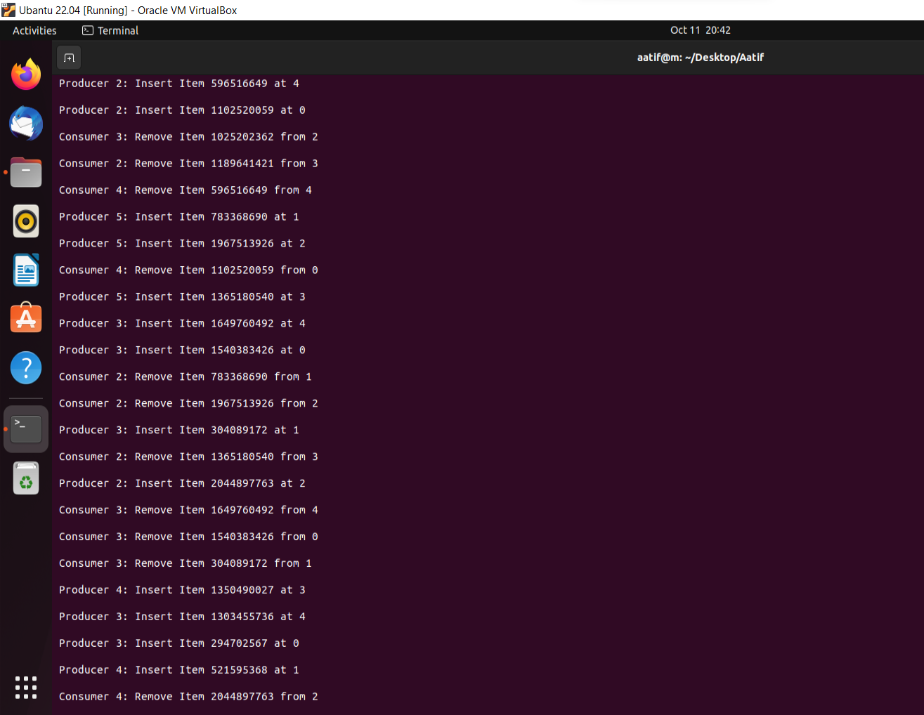

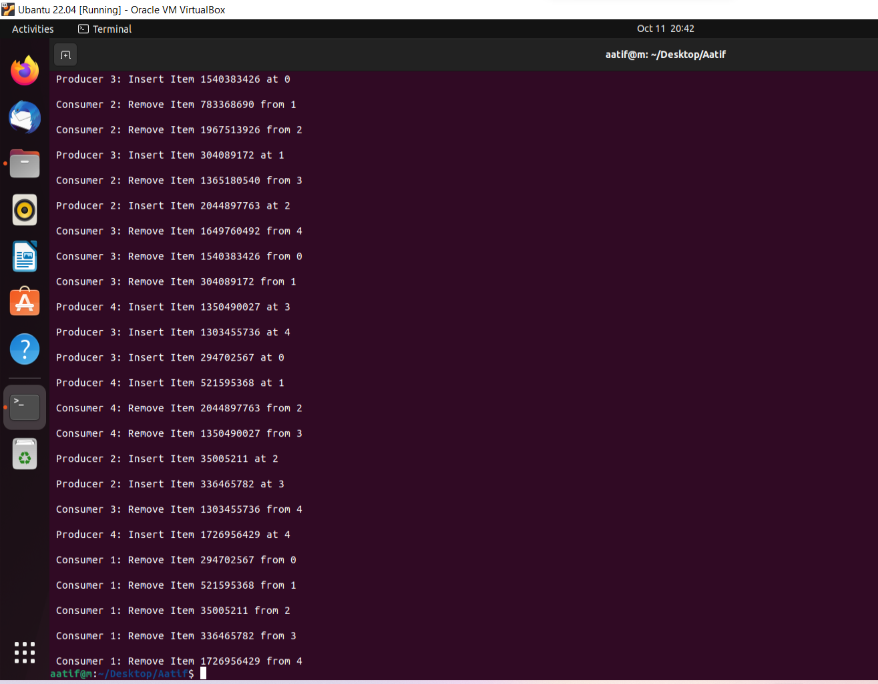

Reader – Writer Problem :
Code :
#include <pthread.h>
#include <semaphore.h>
#include <stdio.h>

sem_t wrt;
pthread_mutex_t mutex;
int cnt = 1;

int numreader = 0;

void *writer(void *wno)
{
sem_wait(&wrt);
cnt = cnt*2;
printf("Writer %d modified cnt to %d\n",(*((int *)wno)),cnt);
sem_post(&wrt);

}
void *reader(void *rno)
{
// Reader acquire the lock before modifying numreader
pthread_mutex_lock(&mutex);
numreader++;
if(numreader == 1) {
sem_wait(&wrt); // If this id the first reader, then it will block the writer
}
pthread_mutex_unlock(&mutex);
// Reading Section
printf("Reader %d: read cnt as %d\n",*((int *)rno),cnt);

// Reader acquire the lock before modifying numreader
pthread_mutex_lock(&mutex);
numreader--;
if(numreader == 0) {
sem_post(&wrt); // If this is the last reader, it will wake up the writer.
}
pthread_mutex_unlock(&mutex);
}

int main()
{

pthread_t read[10],write[5];
pthread_mutex_init(&mutex, NULL);
sem_init(&wrt,0,1);

int a[10] = {1,2,3,4,5,6,7,8,9,10}; //Just used for numbering the producer and consumer

for(int i = 0; i < 10; i++) {
pthread_create(&read[i], NULL, (void *)reader, (void *)&a[i]);
}
for(int i = 0; i < 10; i++) {
pthread_create(&write[i], NULL, (void *)writer, (void *)&a[i]);
}

for(int i = 0; i < 10; i++) {
pthread_join(read[i], NULL);
}
for(int i = 0; i < 5; i++) {
pthread_join(write[i], NULL);
}

pthread_mutex_destroy(&mutex);
sem_destroy(&wrt);

return 0;

}

Output :
